AM – topic 1 self-check – feedback above screenshots

We need to say “….types of searches, such as facilities search, components search, etc.”

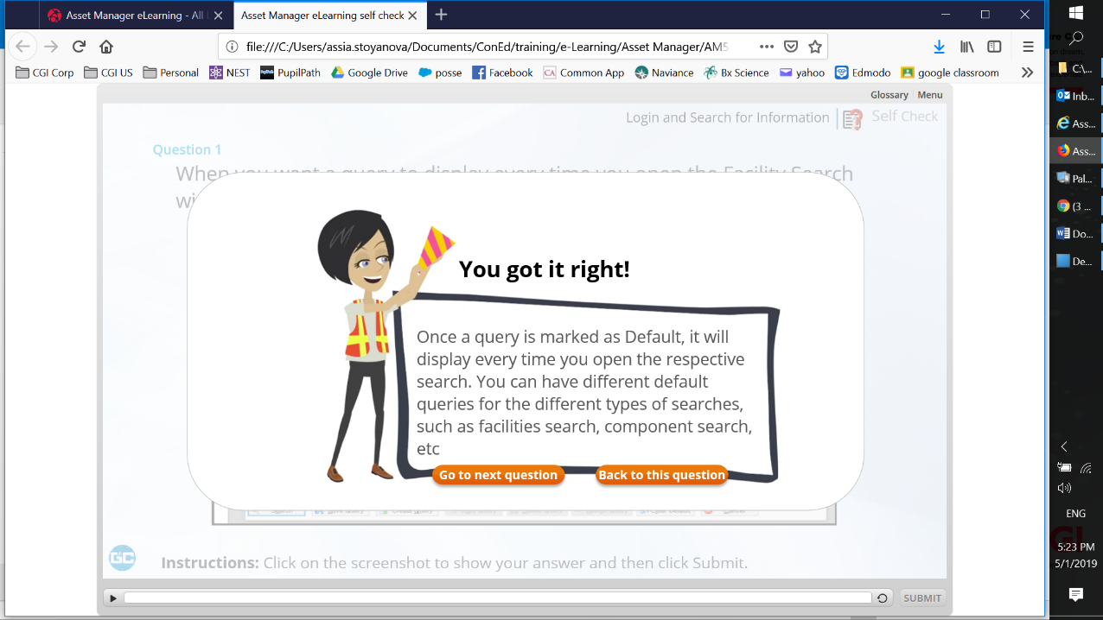

Still an extra space after )
Why question 3 comes before question 2?
Change first bullet to “List of all facilities”
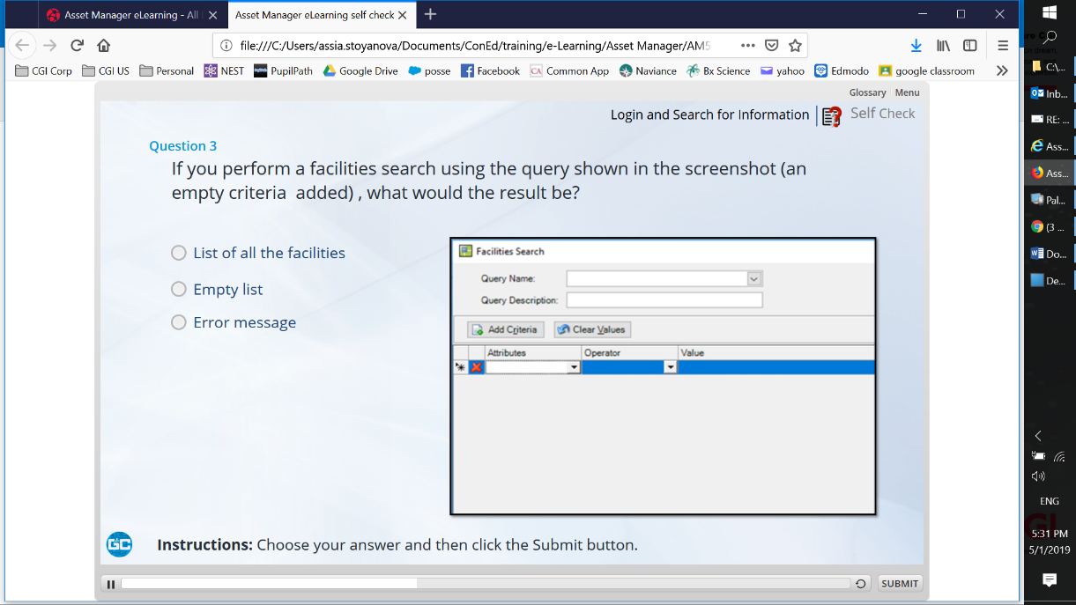

Fuzzy screen shot
Remove extra space after )

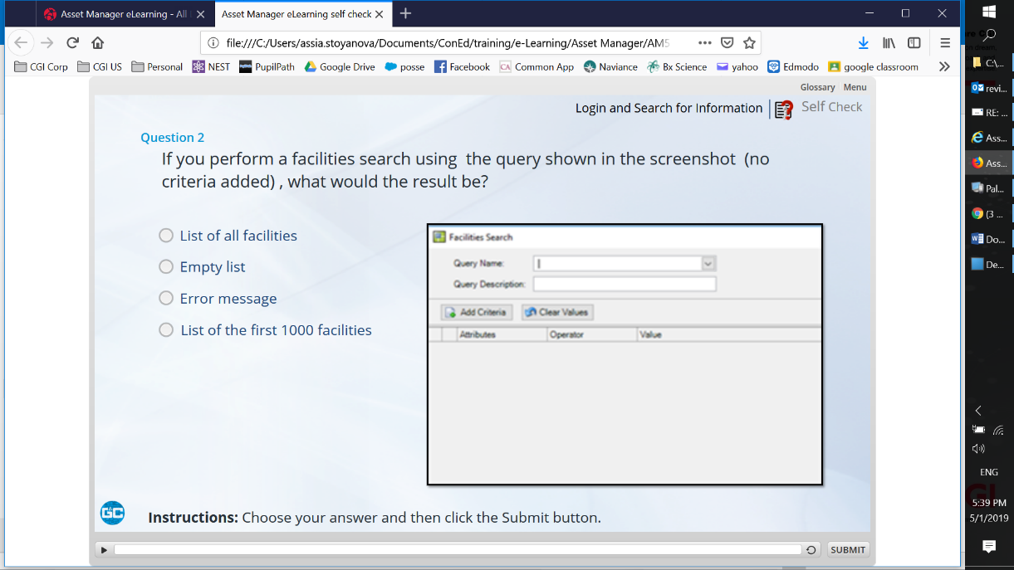

Extra space before “first”

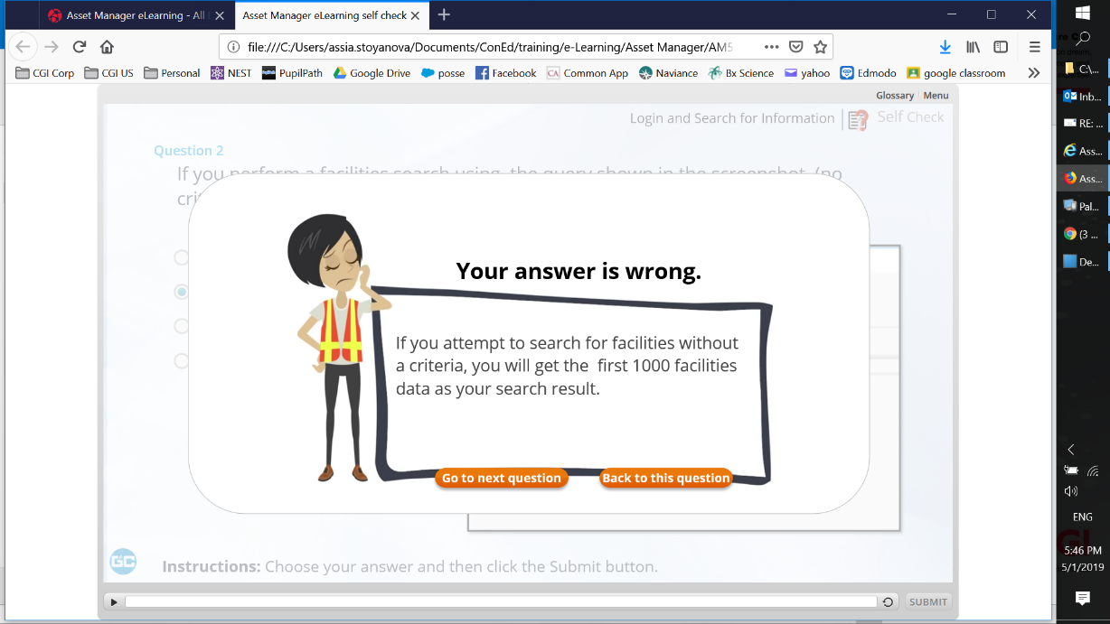

Remove extra space before “a facility” and after “only”
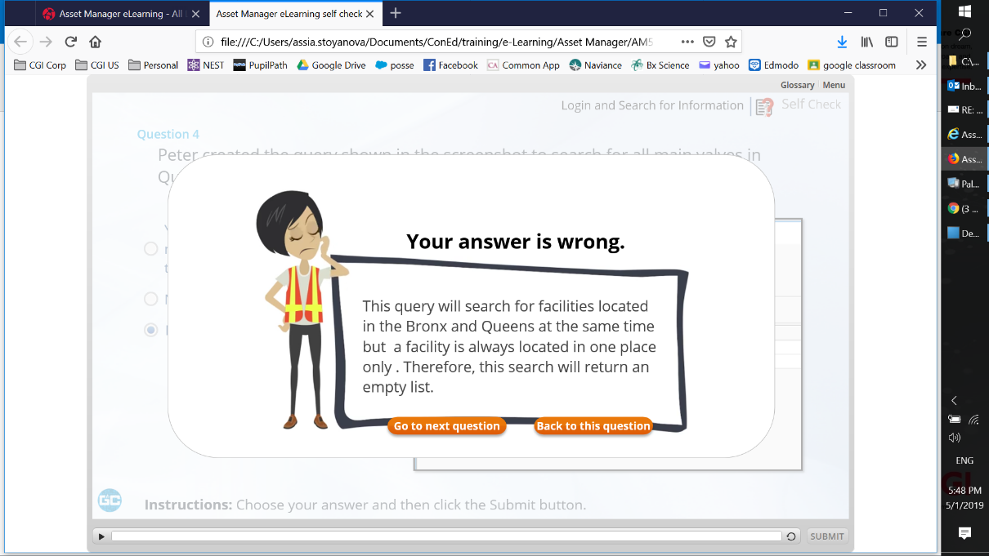

Remove extra space after “Equal to”

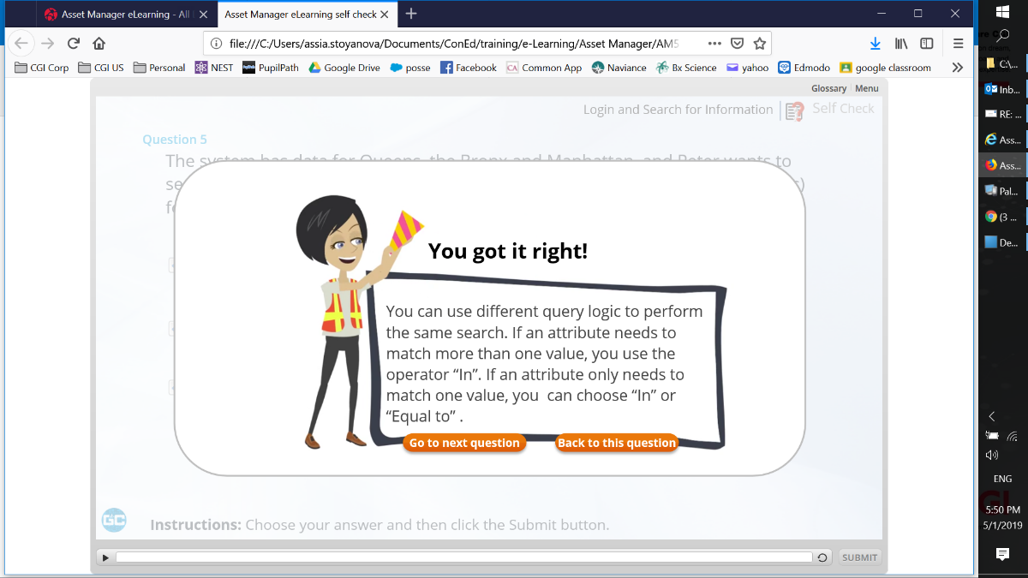

Change to “… search for any facility with an ID that starts with…” or “search for any facilities with IDs that start …”
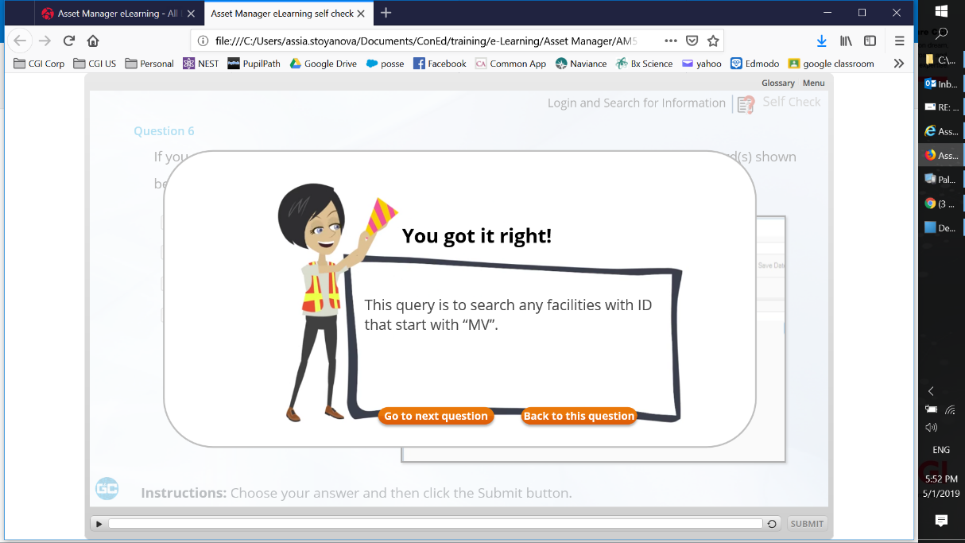

Change “..with IDs that end …” or “with an ID that ends …”
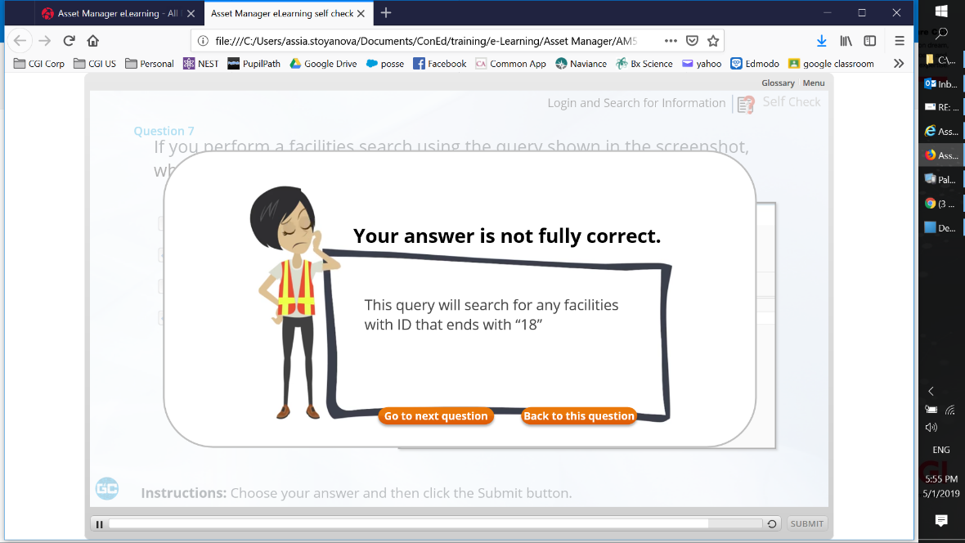

I got the message that my answers was not fully correct but it was fully wrong

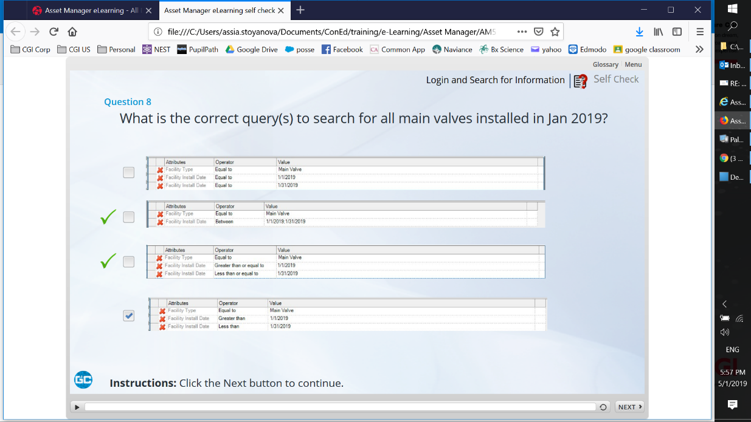

Please add “.” At the end of the sentence

Remove extra space before “about” in the question
Change “;” to “.” as these are full sentences
I got the message that my answer was partially wrong but it was fully wrong

